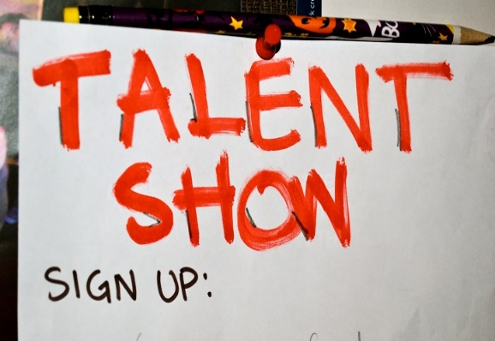
Laukhuf Elementary 2019 Talent Show
What you need to know…
- The talent show is open to any current student at Laukhuf grades K-5.
- You may have a solo act and/or be in a group act.
- You must turn in your permission slip, a CD and the lyrics of your song by May 6th, to Ms. Adams.
- If you are in a group act, every student in the act must turn in a permission slip.
- Tryouts will be held on May 14th. 9:30 5th/2nd grade, 10:15 4th/1st grade, 11:15 3rd/K in the art room. Each act must be ready to perform!
- May 24th the announcement of who was selected for the Talent Show will be posted. We have a limited amount of time for the performance. Acts will be selected with the following criteria…
- Student/groups knowledge of song, dance etc.
- Variety of the acts (not all singers)
- Time restraints
- Act is appropriate for an elementary program.
- The performance is currently scheduled for June 3rd at 2:00. More details will be sent out closer to the performance. Families will be invited.
- All selections by the committee are final. Any questions about the selections are to be forwarded to Ms. Brown.
- All other questions and be emailed to Ms. Adams Toska.adams@jefferson.kyschools.us

Talent Show 2019 Permission Slip
Student Name_____________________________________________
Teacher_____________________________
Kind of act___________________________
Other students in act _________________________________________
___________________________________________________________
Name of the song_____________________________________________
Parent name_________________________________________________
Parent signature______________________________________________
Parent email_________________________________________________
Parent phone #____________________________________
Check the following…
_______ Words attached
_______ CD enclosed

Return sign permission slip, words and CD to Ms. Adams by May 6th.

