Clay classes
Schedule and pricing subject to change.
Please go online for current schedule

Clay Camp full day 9 am – 4 pm No-School days $70
Full-day immersion in clay. Children aged 6 – 12 learn basic hand-building techniques to complete projects, includes forming coils, rolling slabs, joining pieces and glazing.
Kids Class Tues 4 - 6 pm 6-weeks starting September 18 $160
for kids
Children aged 6 – 12 learn basic hand-building techniques to complete projects, includes forming coils, rolling slabs, joining pieces and glazing. Students also have the opportunity to try using the potter’s wheel.

Family Clay Date Sun 2 – 4 pm $30
Children 3+ are welcome at this clay date. Ages 3 – 5 must be with an adult. You choose between using the wheel or hand-building in this single-session class. Seasonally themed projects are provided for hand-building. Optionally have work glazed and fired for additional $10 ($20 for group projects).

All Levels Class Tues 11 am - 1 pm 6-weeks starting October 2 $200
Beginning, intermediate and advanced students are all welcome in this morning class which includes instruction in wheel-throwing and hand-building techniques.
Beginning Wheel Class Tues 6 - 8 pm 6-weeks starting October 2 $200
Beginners receive instruction on using the potter’s wheel in the form of demonstrations and individual assistance. Centering, throwing 1 lb bowls and trimming are covered, as well as introductory glazing and decorating.
For Adults
Intermediate & Adv Class Wed 6 - 8 pm 6-weeks starting October 3 $200
Intermediate and advanced students receive instruction based on individual goals and project ideas. Wheel-throwing and hand-building skills will be demonstrated.
Clay Date Fri / Sat 6 – 8 pm $30
A fun activity for date night or girls' night out. You will receive instruction on how to make a bowl using the potter's wheel and then be set loose to do it yourself (with help where needed!) Make as many bowls as you wish. Optionally have bowls glazed and fired for additional $10 each.
Open Studio Thurs 6 - 8 pm & Sat 11 am – 1 PM Included
Community work period open for all currently enrolled students and members.
Membership Unlimited Access Monthly $50
Membership is an option for those who possess sufficient understanding of clay to work in the studio independently. Members have access to the studio during open hours. ^6 Clay (about $17 bag) and firing ($2 lb) are not included.
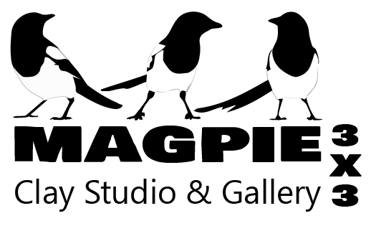 | www.magpie3x3.com  502-919-8992 | Call, stop in or go online to enroll  2210 Frankfort Avenue  Louisville, KY 40206  Off-street parking  Across from The Comfy Cow
We Offer Birthday Parties!

